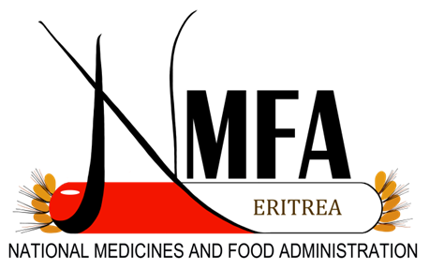**The National Medicines and Food Administration (NMFA) Logo**